**Lab2 (Git, GitHub, ML) 10 points**

**Instructions:**

You have learned about git, GitHub and GitLab. In this lab, you will have hands-on experience by using them in your machine.

Please take necessary screenshot of all the git commands and its execution at each of the steps below.

Step 1: Install git in your local machine (If it is already done, skip this step)

Step 2: Build a ML model for Breast Cancer Wisconsin (Diagnostic) Data set in jupyter notebook. <https://archive.ics.uci.edu/ml/datasets/breast+cancer+wisconsin+(diagnostic>)

Step 3: Please provide screenshots for various stages of the design process (importing data, training, evaluation …)

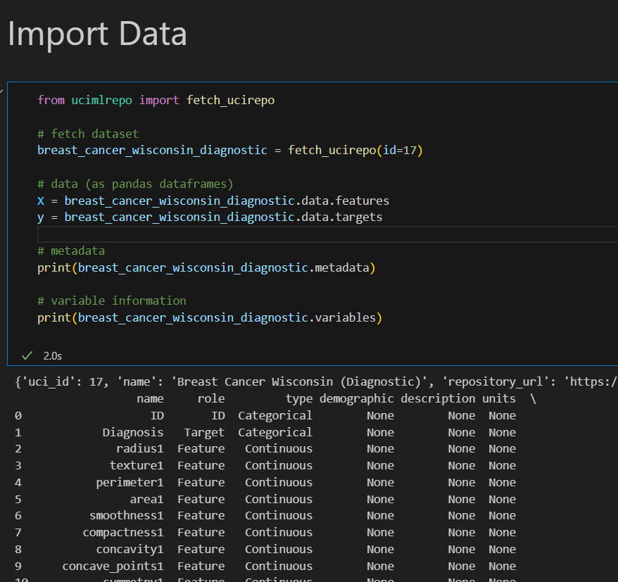

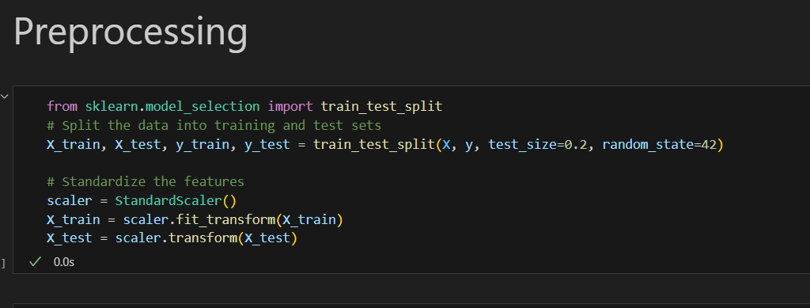

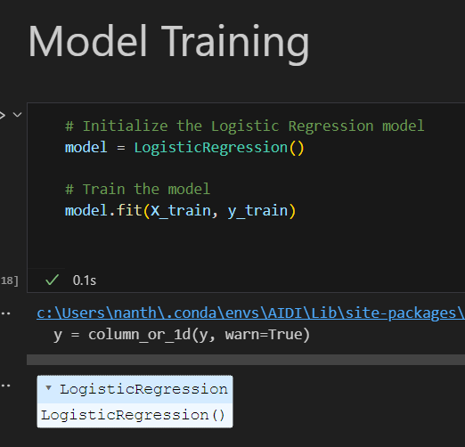

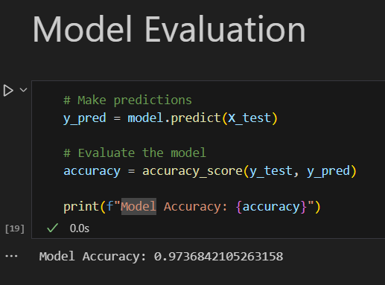

Step 4: Upload your model (Python script, let’s called it <yourname>_model_v1) to GitHub. Provide screenshot of all your git commands and your command prompt showing success of commit of your model files in the remote host.

Step 5: Create a branch in your repo and upload another ML model (may be using a different algorithm and named the file: <yourname>_model_v2) of your choice for the same dataset into that branch.

Step 6: Navigate to your newly created branch and provide screenshot showing status of your repo.

Step 7: Provide a screenshot showing your log of activities and perform your final commit.

Step 8: Provide a description of your program in the README.md file.

Step 9: Make your repo public and share the link of your repo for check.

**Rubrics**

All the above-mentioned steps are completed and all necessary screenshots are provided.

How well the GitHub repository is maintained.

Can I see two branches (master, newly created) in the GitHub repo?

Can I clone your remote repo and easily retrain the models?

**Note:**

Any kind of violation of academic integrity including copying other students work and copying answers directly from Internet will automatically lead to the assignment to be graded as zero.

Late assessments will be subject to a 20% per calendar day late penalty unless otherwise stated by the professor/instructor. Students should communicate to the professor/instructor in advance of the due date for any requests for a due date extension as a result of exceptional circumstances.

**Submission Format:**

1. A single word document including the screenshots of the above steps.
2. The URL to your remote repo.